- The Bank of England's Monetary Policy Committee held Bank Rate at 4% at today's meeting. Additionally, it decided to reduce the stock of gilts held in the asset purchase facility by £70bn over the next year, down from £100bn in the previous year.
- The reduction in the pace of quantitative tightening was broadly in line with our expectations. The MPC appears to have been keen to avoid causing any market stress in arriving at a number close to what market participants had expected.
- The BoE's announcement that it would focus sales more on shorter maturities also reflects a desire to avoid adding to recent upward pressure on yields at the longer end of the curve.
- The minutes made no effort to prepare the ground for a November rate cut. Concerns that inflation expectations may rise seem to be dominating the MPC's thinking. So we expect it to extend the pause for the rest of this year, before resuming loosening policy in early 2026.
The Monetary Policy Committee voted 7-2 to keep Bank Rate at 4% today. But the interest rate decision was a sideshow to the quantitative tightening decision. The committee voted 7-2 to reduce the stock of gilts held in the asset purchase facility by £70bn from October 2025 to September 2026.
This is a slower pace of QT than in the previous year, when the stock of gilts was lowered by £100bn. The decision largely reflects the fact that redemptions are expected to be smaller over the next year, and active sales will be a little higher than before, at £21bn (Chart 1). However, given the volatility in financial markets in recent months, the MPC was keen to avoid surprising markets with a large number and stuck closely to the results of the Bank of England's recent market participants survey (MaPS).
The BoE announced active sales of 40%-40%-20% across short-, medium-, and long-dated gilts, diverging from the previous even split. This adjustment acknowledges challenging market conditions and aims to prevent further upward pressure on long-dated gilt yields.
Chart 1: The MPC's QT decision stuck closely to market expectations
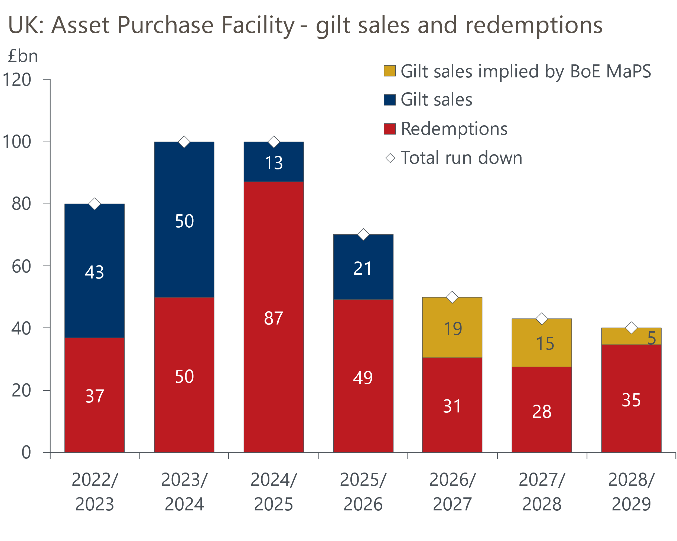
Sources: Oxford Economics calculations using data from Haver Analytics & Bank of England

The MaPS reports that market participants expect the pace of QT to slow further from October 2026, largely because there will be fewer redemptions that year. Whether that happens will likely depend on prevailing market conditions. But today's decision suggests that while the MPC believes that QT has had only a minor impact on markets, the committee is sensitive to the bigger picture and – BoE Chief Economist Huw Pill apart – is no longer wedded to keeping the pace of QT the same each year.

The MPC made no attempt to prepare the ground for a November rate cut
On interest rates, the story was largely as expected. The two dissenters – Alan Taylor and Swati Dhingra – preferred another 25bps cut. The majority continued to balance upside risks from high headline and food price inflation driving up inflation expectations with downside risks from growth and employment.
We think the minutes support our view that the cut-hold tempo to loosening policy will end in November. Coming into today's meeting, market pricing implied just an 11% chance of rates being cut by the November meeting. There was no attempt to push back on this, and as we've previously argued it's hard to see key MPC members, including Governor Andrew Bailey, voting for a cut in the face of such a clear steer from markets. The inclusion of the statement that "upside risks around medium-term inflationary pressures remain prominent in the committee's assessment of the outlook" also gives the impression that most members are more worried about cutting too quickly than too slowly, and that a hold is the default outcome for November.
So we are sticking with our forecast that Bank Rate will remain at 4% for the rest of this year. We expect rate cuts to resume in 2026. By then, the MPC will likely have to factor in the prospect of tighter fiscal policy. We expect growth to miss the BoE's forecasts. And we think there will be better news on wages and inflation, with it becoming apparent to the MPC that the increase in NICs has played a bigger role in this year's stickiness in services inflation.
Overall, though, we think the MPC is likely to proceed slowly, particularly as Bank Rate moves closer to the range that it considers to be equivalent to a neutral policy rate. So we expect just two 25bp rate cuts in 2026, taking Bank Rate to 3.5% at the end of the year.

Key passages from the MPC minutes
"In general, upside risks around medium-term inflationary pressures remained prominent in the Committee’s assessment."
Our interpretation: This was a new addition to the minutes, clarifying that inflation persistence is currently the MPC's key concern. This implies that a hold is the default outcome for November's meeting.
“Seven members preferred to maintain Bank Rate at 4% at this meeting. Alongside a small tightening in financial conditions, there had been limited economic news since the previous MPC meeting, and these members’ views on the main risks and the required strategy to achieve the 2% target sustainably in the medium term had not changed materially. The key question for monetary policy remained whether upside risks to the continuing process of disinflation, from elevated inflation expectations and possible structural changes in price and wage-setting behaviour, could be outweighed by downside risks stemming from the potential for a more substantial weakening in demand. There remained a range of views among these members about the balance of risks to inflation, and the most important factors contributing to it."
Our interpretation: Committee views about the outlook for inflation range widely, with the relative lack of data meaning the story hadn't moved on since the August meeting.
"Two members preferred a 0.25 percentage point reduction in Bank Rate. The disinflation process was continuing. The inflation hump was expected to normalise, with the most significant contributions coming from one-off changes in administered prices and global food inflation in a limited set of items, neither related to demand pressure. Consumer spending and investment remained subdued, while wage settlements had fallen further from around 3.5% in the first half of 2025. Along with domestic demand weakness and emerging slack, recent developments pointed to downward risks to global growth. Given this balance of risks, a less restrictive policy path was warranted to insure against an increased risk of recession, below-target inflation and a further deterioration in supply capacity."
Our interpretation: Alan Taylor and Swati Dhingra have consistently advocated this risk management approach. They appear likely to continue to vote for cuts at upcoming meetings, but as things stand it's hard to see where the other three votes for a cut would come from.
"The Committee judged that a gradual and careful approach to the further withdrawal of monetary policy restraint remained appropriate. The restrictiveness of monetary policy had fallen as Bank Rate had been reduced. The timing and pace of future reductions in the restrictiveness of policy would depend on the extent to which underlying disinflationary pressures would continue to ease. Monetary policy was not on a pre-set path, and the Committee would remain responsive to the accumulation of evidence."
Our interpretation: The committee's broad guidance was identical to last month. The big picture is that the majority expect to cut interest rates further over the coming months, but they are unsure about the pace of cuts or the terminal rate.

